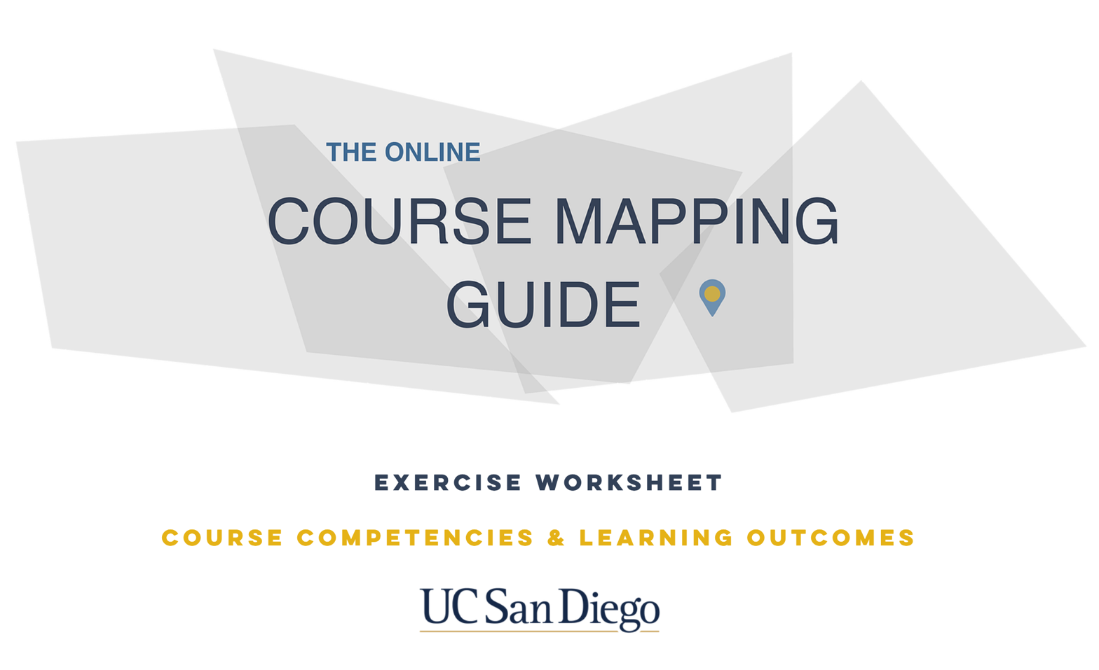

Course Competencies Exercise

Competencies are broad, long-range outcomes that refer to the general aims or purposes of the course that enable learners to successfully perform in professional, educational, and other life contexts.

Try to imagine your learners years from now and think about the critical learning experiences you would want them to have. How might they apply what they’ve learned in this course to their future lives, both personally and professionally? Focus on what learners will be able to know, do and value with a strong focus on real-world applications.
In many instances, you probably already have a good idea of what you want learners to get out of your course even if you haven’t created specific competencies in the past. Reflect on the following questions:
- What do you want learners to take with them from this course?
- What are the core skills, knowledge, and attitudes related to the purpose of those course (does your department have program goals and/or outcomes)?
- How are those skills, knowledge, and attitudes related to the learners’ educational goals and profession?
Examples:
Skill, Knowledge, or Attitude | Competency | Purpose | Real-World, Field, or  Educational Goal Connection  (external standards, if applicable)
Knowledge | Foundational knowledge | Scientific Inquiry | Foundational knowledge of basic physical principles.
Knowledge | Critical thinking & Problem Solving | Scientific Inquiry | Reasoning about scientific principles, concepts, theories, and models.
Skill | Research Ability | Understand what supports the claims | Scientific inquiry and how scientific knowledge is discovered and validated.
Skill | Critical thinking & Problem Solving | Gathering evidence | Discover and analyze information in order to determine its validity for application to a problem.
Skill | Oral, Written, & Digital Communication | Speak confidently and articulately without hesitation | Speaks clearly, fluently and in a compelling manner to both individuals and groups.
Attitude | Understand global context | Cultural appreciation and willing to consider unusual ideas (open thinking) | Develop open attitude and understand new cultures.
Attitude | Self-motivation | Belief in his or her innate ability to achieve goals | Develop the innate ability to achieve goals by maintaining performance under pressure or opposition.
Attitude | Self-reflection | Analyze his or her own capabilities | Have the capacity to evaluate his or her own strengths and weaknesses.
For the purposes of this exercise, you will create two to three competencies for each credit hour of instruction for your course. The competencies you create will provide a vision for your course which will be used in the next step of course design to develop course learning outcomes.
1) Identify the type of competency your course aims to achieve (Knowledge, Skill, or Attitude).

2) Write the corresponding competency.

3) Define the purpose of the competency.

4) Provide the real-world, field, or educational goal connection.

Knowledge | Skill | Attitude
- Facts & Concepts  - Terminology  - Principles  - Theories  - Classifications | - Procedures  - Techniques  - Problem solving  - Critical Thinking | - Ethics  - Morals  - Values  - Personal Characteristics

Skill, Knowledge, or Attitude | Competency | Purpose | Real-World, Field, or  Educational Goal Connection  (external standards, if applicable)

Course Learning Outcomes Exercise

Course Learning Outcomes are specific, measurable statements that refer to the knowledge, skills, and attitudes learners will gain at the completion of a course. Outcomes are written with a verb phrase and declare a demonstrable action within a given timeframe.
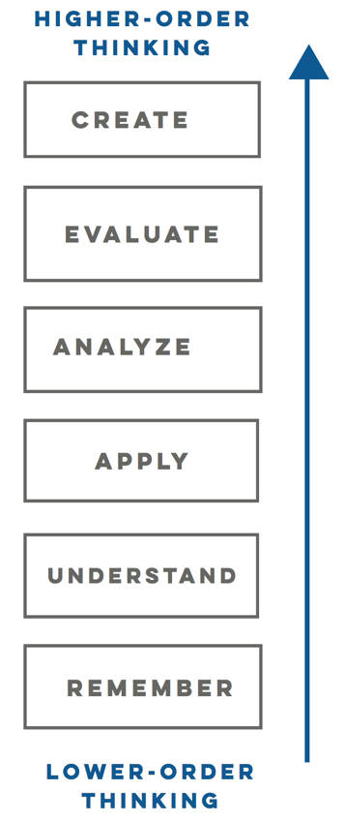
Bloom’s Framework for Writing Learning Outcomes
Bloom’s revised taxonomy provides a framework for transforming competencies into essential learning outcomes or intended results. It is the most widely used and accessible across programs and fields. The taxonomy categorizes six orders of thinking on a continuum of lower-order to higher-order thinking skills:
Remember - retrieve information and relevant knowledge from memory
Understand - construct meaning from instructional messages
Apply - Carry out or using a procedure in a given situation
Analyze - Break into parts and determine how parts contribute to an overall structure or purpose
Evaluate - Make judgments based on criteria and standards
Create - Put elements together to form a new coherent pattern or structure
The categories are on a continuum of increasing cognitive complexity, from lower order thinking skills to higher order thinking skills. A learner who is able to achieve the application level is understood to have already mastered the content at the knowledge (remember) and comprehension (understand) levels.
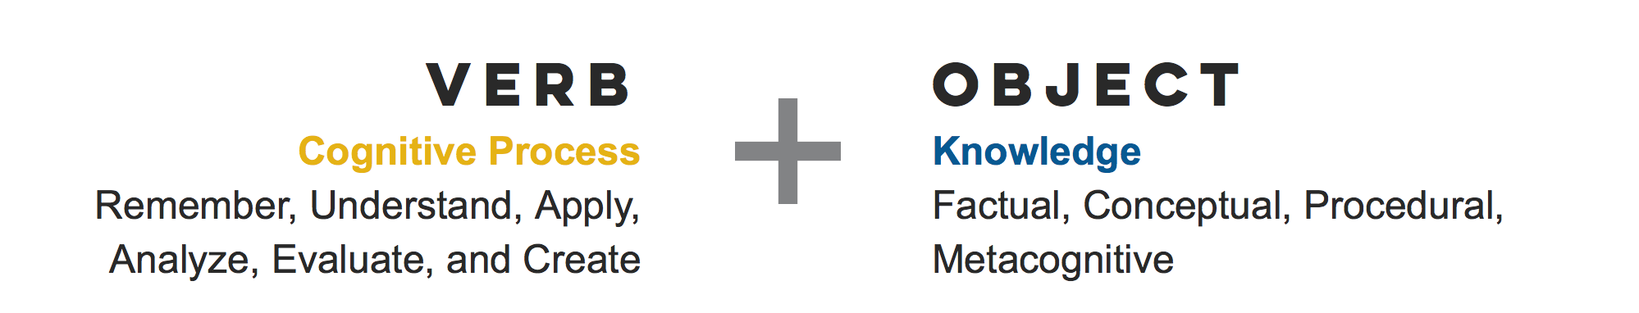
You will take your course competencies and mold them into course learning outcomes. Each course competency should be transformed into at least one course learning outcome, though if needed, you can mold them into multiple outcomes.
You can structure each learning outcome using two parts, a verb and an object, where the verb describes the cognitive process and the noun describes the knowledge students are expected to acquire or construct.

Consider your competencies and construct course learning outcomes to describe how learners will develop competencies through actionable, time-specific deliverables in this course. Effectively articulating a learning outcome involves the structuring of two parts, a verb and an object, where the verb describes the intended cognitive process and the noun describes the knowledge students are expected to acquire or construct (Anderson & Krathwohl, 2001, p. 5).
Resources
Read more about Bloom’s Taxonomy.
Review the Online Course Map Guide’s Course Learning Outcomes page.
Download the Bloom’s Taxonomy Action Verbs Chart.
Examples
Competency | Outcome
Have an engaging and impactful writing style using figurative language | Identify and define the following types of figurative language: personification, metaphors, similes, idioms, and clichés.
Understand how agricultural revolutions impacted early civilizations. | Explain the characteristics of the Neolithic Revolution and its impact on the early civilizations.
Break down complex data and identify key information. | Interpret data sets and communicate those interpretations using visual and other appropriate tools.
Foundational knowledge of basic physical principles. | Define principles of electricity and magnetism (e.g., charge, current flow, resistance, capacitance, electrical potential, and magnetic fields).
Learning Outcomes
By the end of this course, learners will be able to:

